# Tutorial 3.2

Stimulated an AELIF neuron with the required parameters. (line 1 - 50)

1. Set noise level to 50 pA∙s^0.5
   1. Plotted the histogram of ISIs, 25 bins (line 52 - 62)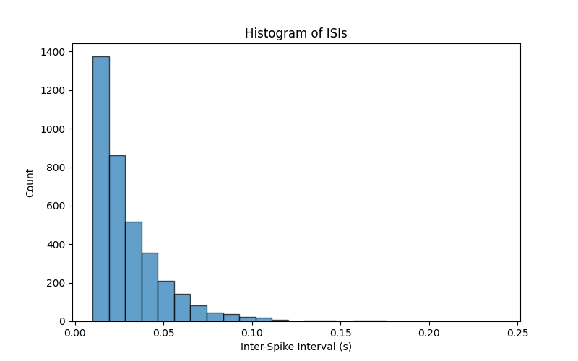
   2. The CV of the ISIs (the standard deviation divided by the mean) was calculated to be **0.813**. (line 64 - 66)
   3. Calculated the Fano factor by the number of spikes in each consecutive 100ms window to be **0.637**. (line 68 - 73)
   4. Plotted Fano factor against window-size range from 10ms up to 1 second. (line 75 - 92)
2. Repeated with AELIF parameter b = 1nA.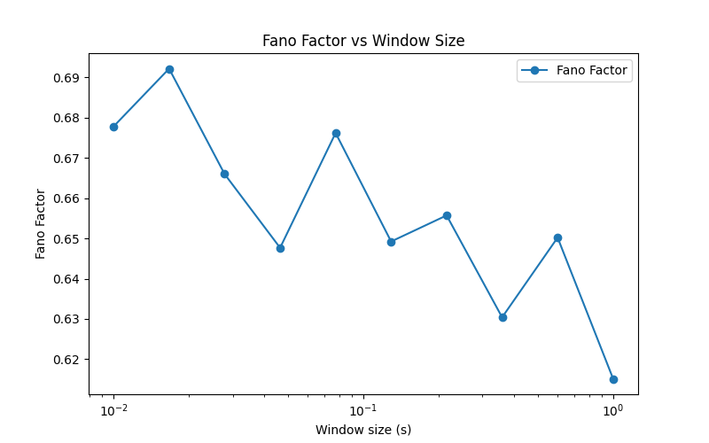
   1. Histogram of ISIs.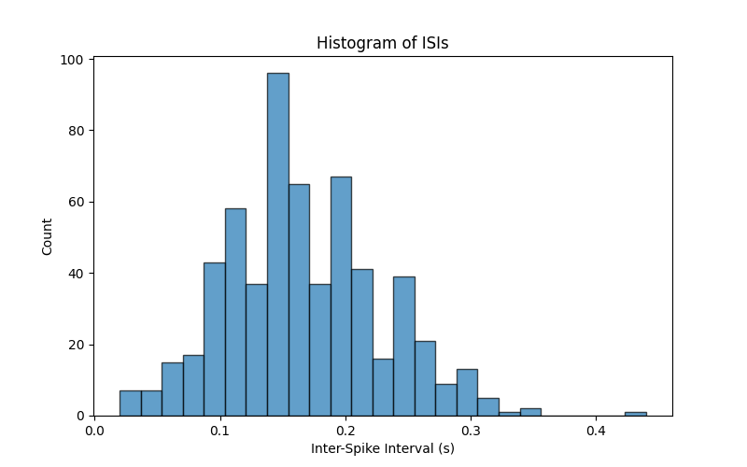

By comparing the results to part (a), I found that the distribution of ISIs is much higher and more normal. This makes sense because the adaptation strength increases after each spike, making subsequent spikes less likely. The inter-spike intervals will shift to the right.

* 1. The CV of the ISIs (the standard deviation divided by the mean) was calculated to be **0.368**.

The CV is significantly lower than in the part (a). Considering the formula, this should be caused by the increased mean of ISIs which divides the CV.

* 1. Calculated the Fano factor by the number of spikes in each consecutive 100ms window to be **0.472**.
  2. Plotted Fano factor against window-size range from 10ms up to 1 second.

The Fano factor fluctuates across different window sizes in part (a) while shows a stability diminishing curve in part (b). Clearly the adaptation strength has an effect on the variance of fano factors depending on the window sizes. The Fano factors have high variability at short timescales and over longer periods, the spike count becomes more stable. The absence of adaptation strength might have caused the irregular pattern of spikes because it is noise-dominant.

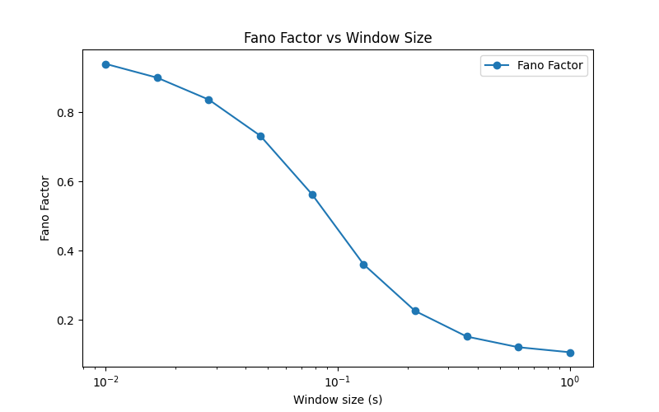

1. AELIF parameter b = 0nA, while reducing the noise to set 𝜎 = 20 pA∙s0.5. Input current constant terms of 0nA, 0.1nA, and 0.2nA.
   1. Histogram of ISIs.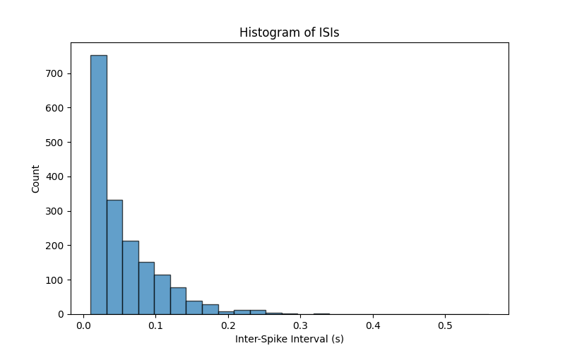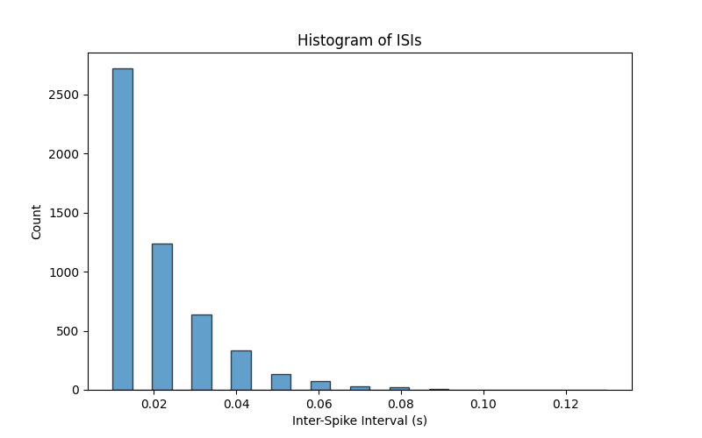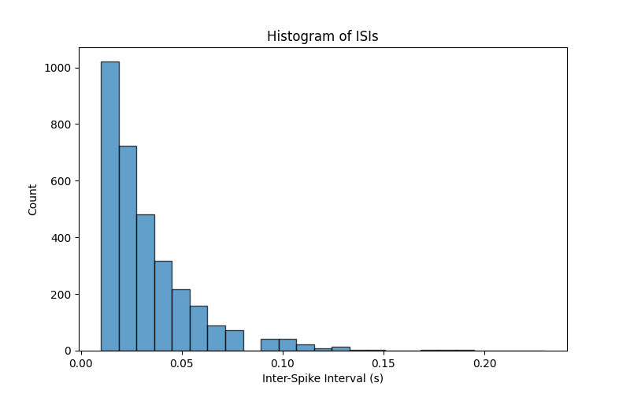

The results are quite close to part (a) since adaptation strength is neglected in this stimulation. The ISIs are smaller with increased input currents, as more firing is produced.

* 1. The CV of the ISIs (the standard deviation divided by the mean) was calculated to be **0.901**, **0.817**, and **0.686** respectively.

The CV declined as the input currents increased, which suggests smaller variation in ISIs. This can be interpreted as larger input current reduces the effect of noise.

* 1. Calculated the Fano factor by the number of spikes in each consecutive 100ms window to be **0.827**, **0.629** and **0.457**.

The decreasing Fano factor also aligns with the observation in the change in CV. As the input current increases, the variation is reduced.